CS331 : PROJECT

Online Railway Reservation System

Software Engineering Project

Abhishek Raj

Roll : 1301004

**Table of Contents**

1. **INTRODUCTION** 
   1. Objective

**DIAGRAM**

Use Case Diagram

Class Diagram

State Diagram

Sequence Diagram

Data flow Diagram

Component Diagram

# Functional Requirements

1.1 Objective:

The purpose of this source is to describe the railway reservation system which provides the train timing details, reservation, billing and cancellation on various types of reservation namely,

• Confirm Reservation for confirm Seat.

• Reservation against Cancellation.

• Waiting list Reservation.

• Online Reservation.

• Tatkal Reservation.

Use-case Diagram

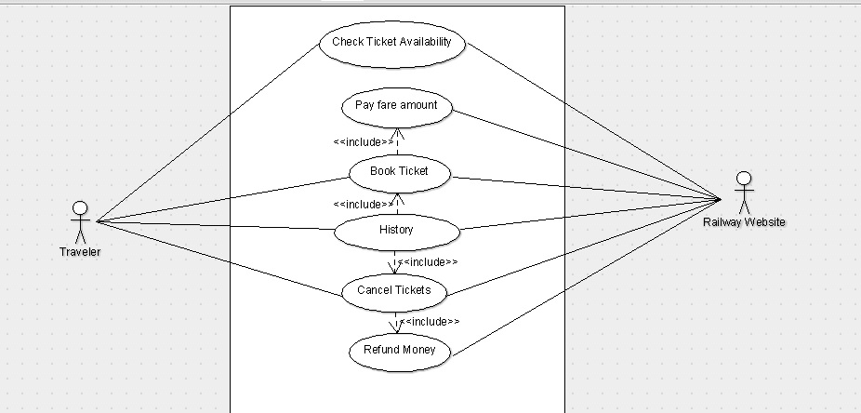

Customer / End User Activities

The above use case diagram depicts all the functions or activities that a user or a customer can perform on the application. They can be discussed in detail as follows:

**Home Page:**  the user can access the user train Reservation System website, after he logs into the system. Here, he can look up information regarding train.

**Login and Register:** Railway Reservation System also comes with the customer registration details page, where the customer can enter his details and register. He can also create a username and password.

**Booking Tickets:** The customer can also search for the train available and reserve his place on the train by purchasing a ticket.

**Administrator Activities**

**Login/Logout:** The administrator has to login first in order to be able to make changes to the Railway Reservation System, by adding, deleting or modifying the data in the Railway Reservation System database. After making the necessary changes, he then has to logout of the system, in order to prevent misuse of the data.

**Add/Modify Bus Information:** The Administrator also has the sole rights to add, delete or modify the train information. Sometimes, bus get cancelled for some reason, so such bus would be removed from the list of bus available to the customer. Similarly, whenever any bus information has to be modified or if any new train need to be added to the database, these operations are performed by the administrator.

# Functional Requirements

The functional requirements of the Railway Reservation System are divided among the customer and the administrator of the application. These functional requirements can be explained in detail as follows:

* 1. ***Use Case name: User Online Enquiry***
* **Description:** This use case describes the scenario where the user views the status of train availability and seat availability.
* **Actor:** User or the customer.
* **Input:** After the customer logs onto the application with his username and password, he provides the details of his journey.
* **Output:** The application shows the availability status of train and seats.
  1. ***Use Case name: Book Tickets***
* **Description:** This use case describes the scenario where the user reserves the train ticket.
* **Actor:** User or the customer.
* **Input:** After the customer logs onto the application with his username and password, he provides the details of his journey and passenger details.
* **Output:** The application verifies the journey details and if train and seat will be available, it reserves the ticket.
  1. ***Use Case name: History***
* **Description:** This use case describes the scenario where the user views his booking history.
* **Actor:** User or the customer.
* **Input:** After the customer logs onto the application with his username and password, he can look up at the history.
* **Output:** The application shows the booking history.
  1. ***Use Case name: Cancel Tickets***
* **Description:** This use case describes the scenario where the user can cancel the tickets.
* **Actor:** User or the customer.
* **Input:** After the customer logs onto the application with his username and password, he provides the details of his tickets.
* **Output:** The application cancels the ticket and update the database.
  1. ***Use Case name: Picture Gallery***
* **Description:** This use case describes the scenario where the user views the pictures of the bus.
* **Actor:** User or the customer.
* **Input:** After the customer logs onto the application with his username and password, he can look up at the picture gallery.
* **Output:** The application shows the pictures of the train from outside as well as inside.
  1. ***Use Case name: Admin login / log out***
* **Description:** This use case describes the scenario where the admin logs in the system and logs out after finishing the work.
* **Actor:** Administrator.
* **Input:** Administrator of the website logs in with the userId and password provided to him.
* **Output:** The application verifies the authenticity and displays the home page of the administrator on successful authentication.
  1. ***Use Case name: Add / Delete / Modify Bus Details***
* **Description:** This use case describes the scenario where the administrator adds, deletes or modifies bus information in the application database.
* **Actor:** Administrator.
* **Input:** The administrator logs onto the system with the username and password provided to him.

**Output:** The application authenticates the administrator, by verifying the username and password. Then the application displays the page where the administrator can add new train to the database, delete the buses that have been cancelled or modify information for the train

Class Diagram

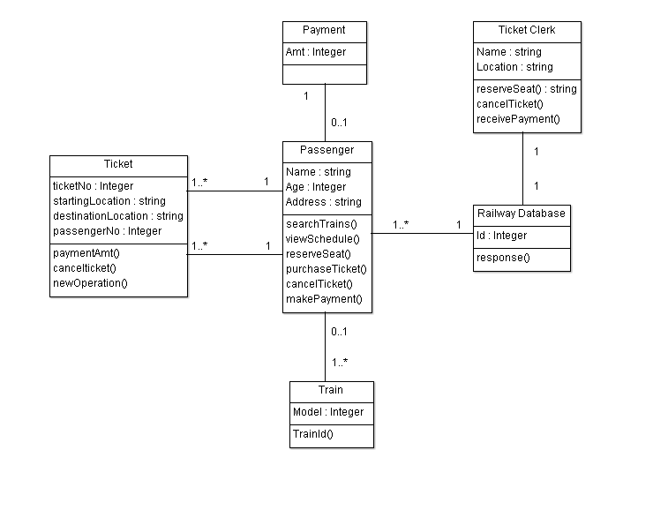

DATA FLOW DIAGRAM

LEVEL : 0 & 1

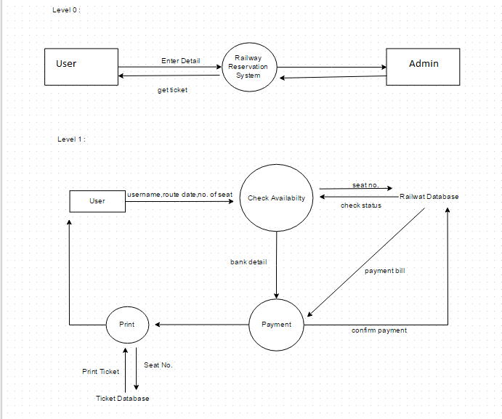

LEVEL : 2

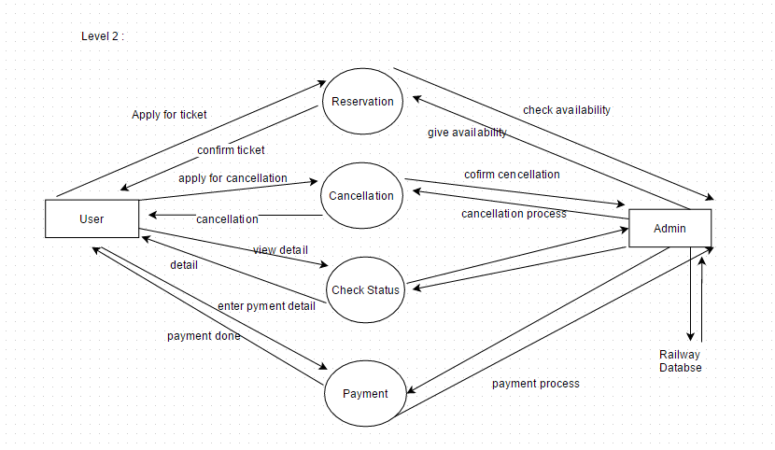

SEQUENCE DIAGRAM

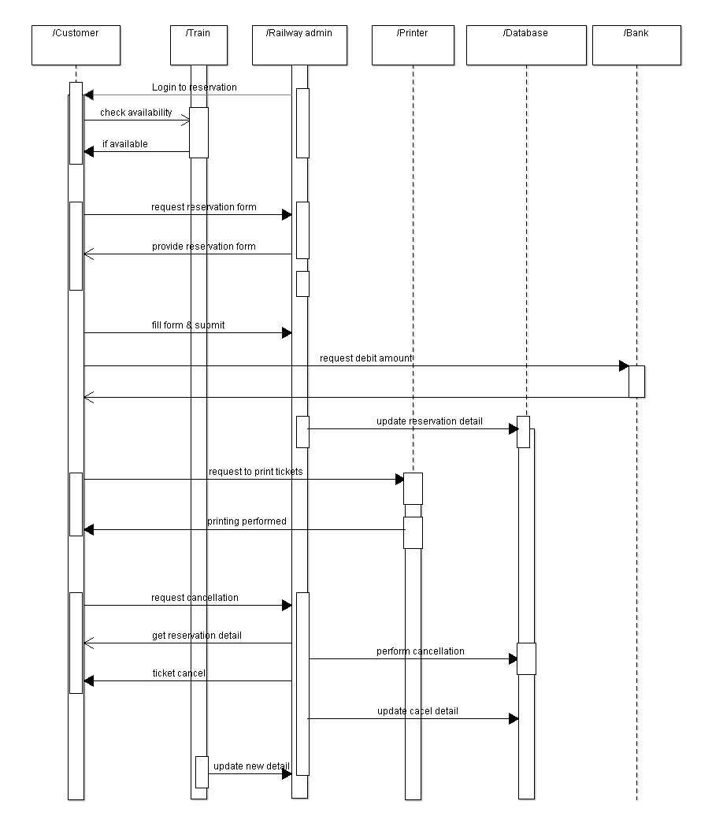

STATE DIAGRAM

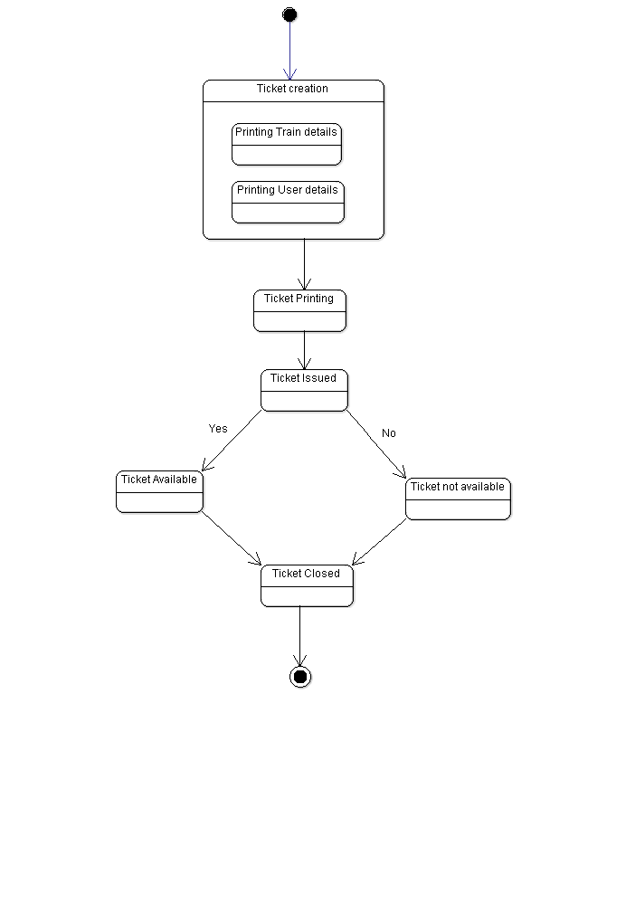

COMPONENT DIAGRAM

